MCP

What is MCP?
MCP (Model Context Protocol) is a standard way for AI systems to connect with different data sources like Jira, Slack, or GitHub — all using one common protocol instead of building separate custom connectors for each system.
Why MCP?
Normally, if an AI app needs data from multiple tools (e.g., Jira + Slack), developers must create a separate API connection for each — which is time-consuming and hard to maintain.
MCP solves this problem by acting as a universal bridge between AI and different data systems.

How MCP Works (3 Layers)
Layer | Role | Example
Host | The AI app that starts the connection | ScrumHero
Client | The connector inside the AI app | MCP Client inside ScrumHero
Server | The external tool providing data | Jira MCP Server

Simple Data Flow
- Connect: ScrumHero connects securely to Jira using MCP.
- Ask: User says — “Show Ananya’s in-progress tickets.”
- Translate: MCP converts this request into Jira’s API language.
- Fetch: Jira sends back the ticket data.
- Display: ScrumHero shows the result in an easy-to-read way.
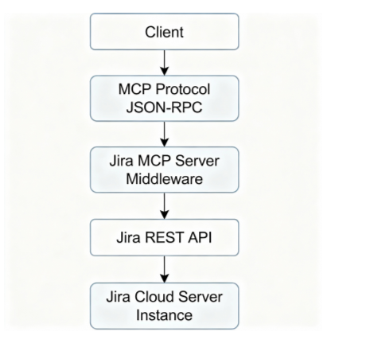

What MCP Servers Can Do
- Resources: Access data (tickets, sprint info, team details).
- Tools: Perform actions (fetch, update, summarize).
- Prompts: Give ready-made templates (e.g., stand-up summaries).
- Roots: Set boundaries (like project folders or URLs).
- Elicitation: Ask users for more details if needed.

Benefits for ScrumHero

Development
- No need to build custom API connections.
- Follows an industry standard used by big companies (Block, Apollo, etc.).
- Easier to update and maintain.

Functional
- Get live Jira data instantly.
- Understands natural language queries.
- Remember context across chats.
- Can both read and update data.

Security
- Uses token-based secure connections.
- Respects Jira permissions.
- Keeps all data encrypted.

Conclusion
MCP = One smart bridge that connects AI apps (like ScrumHero) to many data sources securely and easily.
It helps developers save time, reduces complexity, and supports future tools like Slack, GitHub, and more — making it perfect for real-time, data-driven AI applications.

LANGGRPAH-OMAS

LangGraph-Orchestrated Multi-Agent System (OMAS)
A Multi-Agent System (MAS) means the workflow is divided among specialized “agents,” each doing a specific job.
A LangGraph organizes these agents and the data flow between them.
Think of it like a factory assembly line:
- Each station (agent) has a job.
- The LangGraph passes the “product” (data) along.
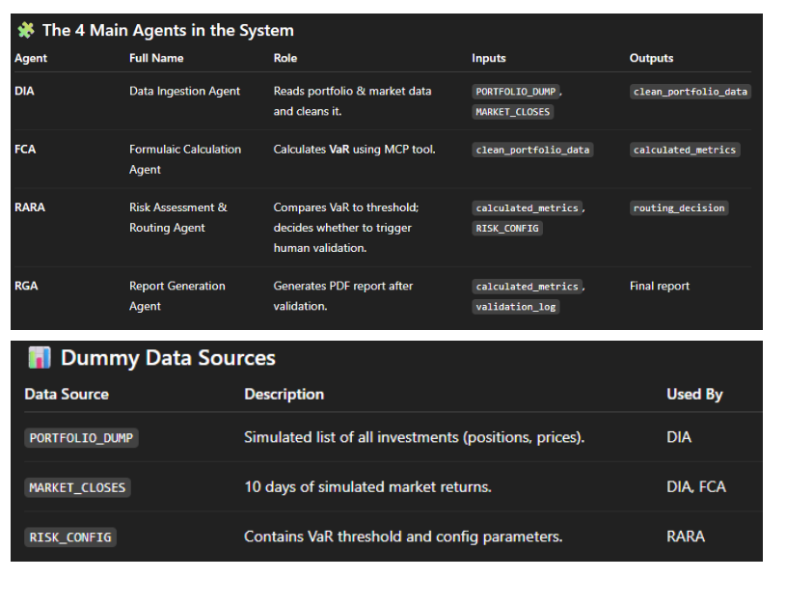

AGENTS
AGENTS

1. DIA – Data Ingestion Agent

Definition:
The Data Ingestion Agent (DIA) is the starting point of the system.
It is responsible for reading, collecting, and cleaning all the input data that will be used in the financial risk calculation process.

Usage:
- It gathers data from two main dummy sources:
- PORTFOLIO_DUMP → contains details of the firm’s investments (assets, quantities, prices, etc.)
- MARKET_CLOSES → contains historical market data (returns for past 10 days)
- DIA then normalizes and formats this data into a structured format (clean_portfolio_data) so that the next agent (FCA) can process it without errors.

Example:
Imagine the DIA as a data cleaner.
It reads:
APL-1 → 1000 shares @ $150.20
TSL-2 → 500 shares @ $280.50

And market returns like:
Day-1: APL-1 → -0.035, TSL-2 → -0.040

It combines and prepares them into a clean dataset such as:
{
"APL-1": {"quantity": 1000, "price": 150.2},
"TSL-2": {"quantity": 500, "price": 280.5}
}
So DIA’s job is to prepare the raw input data for calculation.

2. FCA – Formulaic Calculation Agent

Definition:
The Formulaic Calculation Agent (FCA) performs the core financial computation — calculating the Value at Risk (VaR) by using the MCP (Model Calculation Platform) tool.

Usage:
- FCA takes the cleaned data from DIA (clean_portfolio_data)
- Sends it to the MCP Tool — specifically, the function compute_historical_var()
- The MCP Tool:
  - Simulates 10 hypothetical market scenarios
  - Calculates portfolio profit or loss for each
  - Identifies the worst possible loss (VaR₉₉)
- FCA then collects:
  - VaR_99 → the calculated risk value
  - pnl_distribution → list of profit/loss outcomes
  - mcp_audit_id → tracking ID for the calculation

Example:
If your total portfolio is worth $2,561,300,
and after testing 10 scenarios, the worst 1-day loss was $650,500,
then:
{
"VaR_99": 650500.00,
"mcp_audit_id": "VAR-RPT-482937"
}
So FCA’s job is to calculate the financial risk (VaR) and provide verifiable results.

3. RARA – Risk Assessment & Routing Agent

Definition:
The Risk Assessment & Routing Agent (RARA) acts as a decision-maker.
It checks whether the calculated risk (VaR) exceeds a predefined threshold and decides the next step in the workflow.

Usage:
- It reads:
  - calculated_metrics from FCA (the VaR value)
  - RISK_CONFIG file (contains threshold = 550,000)
- It compares the two:
  - If VaR₉₉ > threshold → “BREACH”
  - If VaR₉₉ ≤ threshold → “CLEAR”
- Based on this, it routes:
  - “BREACH” → sends data to Human-in-the-Loop (HITL) for review
  - “CLEAR” → goes straight to Report Generation Agent (RGA)

Example:
If:VaR_99 = 650,500 → exceeds 550,000 → “BREACH”
then the system pauses for human review.
If:VaR_99 = 325,450 → below 550,000 → “CLEAR”
then it moves directly to report generation.
So RARA’s job is to check the risk against limits and decide the workflow path.

4. RGA – Report Generation Agent

Definition:
The Report Generation Agent (RGA) is the final stage in the workflow.
It generates the daily PDF risk report that summarizes all calculations, decisions, and validations.

Usage:
- It collects:
  - calculated_metrics (VaR value)
  - validation_log (if HITL review was done)
  - mcp_audit_id (audit reference)
- It compiles these into a readable and auditable report for stakeholders (risk team, compliance, etc.)
- The report includes:
  - Key metrics (VaR, threshold)
  - Compliance status (“CLEAR” / “BREACH”)
  - Portfolio breakdown
  - Audit trace

Example:
A generated report might look like:
RISK REPORT (Date: Oct 13, 2025)
---------------------------------
VaR (99%, 1-Day): $325,450
Threshold: $550,000
Status: CLEAR
Portfolio Value: $2,561,300
Audit ID: VAR-RPT-482937
Validation Notes: Auto Approved (No Breach)
So RGA’s job is to create a complete, traceable, and compliant risk report.

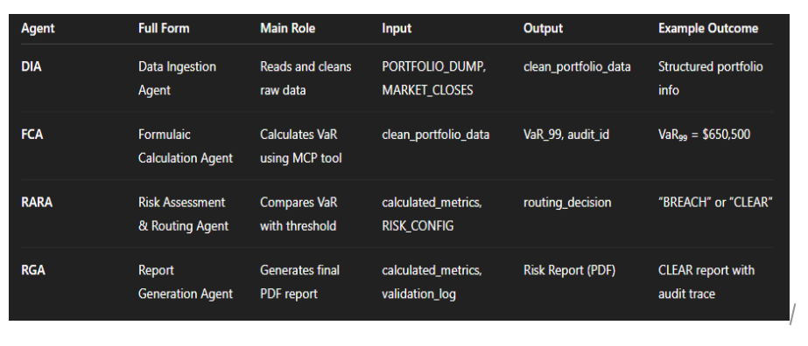

FLOW CHART EXPLANATION
FLOW CHART EXPLANATION
This flowchart shows how the LangGraph-Orchestrated Multi-Agent System (OMAS) automates daily financial risk calculation using multiple agents.
Each “Agent” has its own job:
- DIA → Gets data
- FCA → Calculates risk
- RARA → Checks risk vs limit
- RGA → Generates final report
If the risk is too high, a human steps in to review (HITL).
If it’s safe, the system automatically completes the report.

Step-by-Step Explanation

1. START (Daily System Trigger)
- The system begins automatically every day.
- This trigger is like a daily alarm that starts the workflow.
- Purpose: to calculate the daily financial risk for the portfolio.
Keywords:
- Trigger Event → an automated signal that starts a process (like a cron job or scheduler).

2. DIA – Data Ingestion Agent
What it does:
- This is the first agent. It collects all the necessary input data.
- It reads from two files:
- PORTFOLIO_DUMP → contains all assets, their quantities, and prices.
- MARKET_CLOSES → contains 10 days of historical market data (returns).
- Then it cleans and formats this data so it’s ready for calculation.
- It outputs this cleaned data as clean_portfolio_data.
In simple words:
DIA collects and organizes all the information that the system will use to calculate risk.

Keyword meanings:
- Ingestion → Taking in data from different sources.
- Normalization → Making sure the data is clean, consistent, and in a usable format.
- Portfolio → The collection of assets owned by the firm (stocks, bonds, forex, etc.).

3. FCA – Formulaic Calculation Agent
What it does:
- The second agent in the flow.
- It sends the cleaned data to a special external system called the MCP Tool (Model Calculation Platform).
- The MCP Tool performs the VaR (Value at Risk) calculation using a method called Historical Simulation.
- After the calculation, FCA receives:
- VaR_99 → Value at Risk (the estimated worst-case loss)
- pnl_distribution → list of profit/loss values from simulations
- mcp_audit_id → a unique ID to track this specific calculation
In simple words:
FCA is the “math brain” of the system. It figures out how much money could be lost in a worst-case market situation.
Keyword meanings:
- VaR (Value at Risk) → The maximum potential loss in a portfolio over one day, with 99% confidence.
Example: “VaR₉₉ = $650,500” means there’s only a 1% chance the loss could be worse than $650,500.
- MCP Tool → A certified external program that runs the official risk calculation.
- Audit ID → A tracking code (like a receipt) that proves the calculation was done properly.

4. MCP Tool (RiskCalc Server)
What it does:
- This is the actual engine that performs the risk math.
- Function used: compute_historical_var().
- It takes:
- Portfolio data
- 10 days of market returns
- Confidence level (99%)
- It outputs:
- VaR_99 → the worst loss
- P&L list → all simulated profit/loss results
- mcp_audit_id → record for audit trail
In simple words:
The MCP Tool simulates how your portfolio would perform if the past 10 days of market movements happened again.
Keyword meanings:
- Historical Simulation → Risk is calculated based on real past data.
- P&L (Profit & Loss) → The amount of money gained or lost in each scenario.
- Confidence Level (99%) → The reliability level of the risk estimate.

5. RARA – Risk Assessment & Routing Agent
What it does:
- Takes the VaR_99 value from FCA.
- Reads the threshold from RISK_CONFIG (e.g., 550,000).
- Compares the two values:
- If VaR > threshold → “BREACH”
- If VaR ≤ threshold → “CLEAR”
- Depending on the result, it routes the workflow:
- “BREACH” → goes to Human-in-the-Loop (HITL) review
- “CLEAR” → goes directly to report generation (RGA)
In simple words:
RARA decides whether the portfolio’s risk is acceptable or needs a human check.
Keyword meanings:
- Threshold → The maximum safe limit of risk.
- BREACH → Risk exceeds the safe limit (needs review).
- CLEAR → Risk is within acceptable limits.
- Routing → Sending the workflow down the correct path.

6. Decision Point – “VaR > 550K ?”
What happens here:
- The system checks the condition:
- If VaR is more than $550,000 → BREACH (High risk).
- If VaR is less or equal → CLEAR (Safe).
In simple words:
This is the “Yes or No” gate — it decides which path to follow next.

7. HITL – Human-in-the-Loop Review (if BREACH)
What it does:
- A human analyst steps in when risk is too high.
- They check the data, calculations, and assumptions.
- They may approve, reject, or add comments.
- Updates the validation_log with notes and status.
In simple words:
When the system detects a risky situation, a human double-checks it before finalizing the report.
Keyword meanings:
- HITL (Human-in-the-Loop) → A safety step where a person validates the system’s decision.
- Validation Log → Record of who checked and what was decided.

8. RGA – Report Generation Agent (if CLEAR)
What it does:
- Automatically creates a PDF report summarizing the day’s risk.
- Includes:
- VaR value
- Threshold
- Compliance status (CLEAR or BREACH)
- Portfolio summary
- Audit ID
- Validation notes (if reviewed)
- Stores it for audit and compliance teams.
In simple words:
RGA is like the “report writer” — it takes all results and produces a clear, auditable daily summary.
Keyword meanings:
- Compliance Status → Whether the risk is acceptable under firm rules.
- Audit Trail → A record showing that every step can be traced and verified later.

9. Final Risk Report (PDF)
What it contains:
- Status: “CLEAR” or “BREACH”
- VaR_99 and threshold value
- Portfolio breakdown
- Audit ID and validation notes
- Stored securely for audit purposes.
In simple words:
This is the final output — the daily risk report used by management and auditors.

10. END (Report Archived Daily)
What happens here:
- The process ends after the report is stored.
- The system is ready for the next day’s trigger.
In simple words:
The daily workflow finishes, and everything is archived for transparency.

UV PACKAGE MANAGER

What is uv?
uv is a modern, ultra-fast Python package and project manager developed by Astral (the same team behind Ruff — the Python linter).
It is designed to be a drop-in replacement for traditional tools like:
- pip (for package installation)
- pip-tools or pipenv (for dependency management)
- venv (for virtual environments)
- and even parts of poetry
So you can think of uv as an all-in-one tool that makes Python dependency management and environment setup much faster and simpler 🚀.
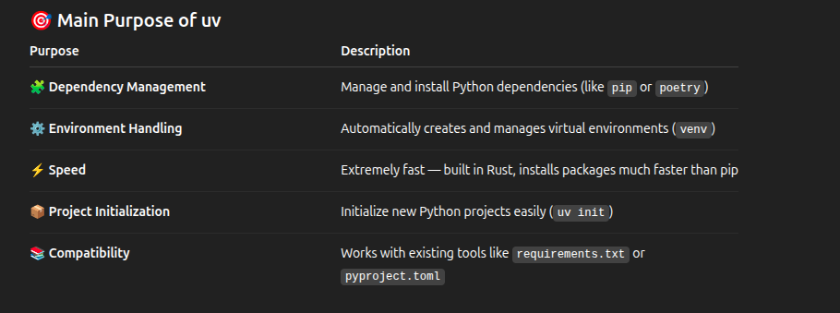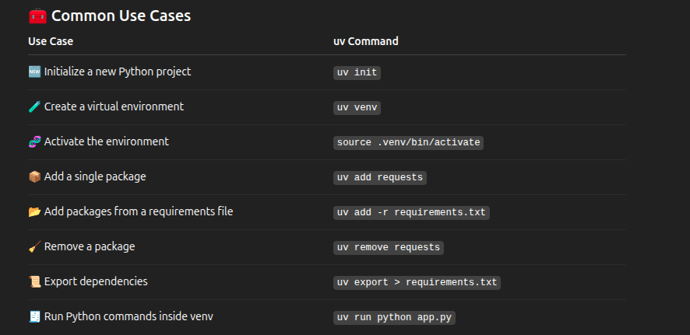
Installation on Linux
You already have it right
curl -LsSf https://astral.sh/uv/install.sh | sh

This script downloads and installs uv on your system.
Once done, you can verify:
uv --version
Typical Workflow Example
Here’s how a full setup might look like 👇
# 1️⃣ Install uv
curl -LsSf https://astral.sh/uv/install.sh | sh

# 2️⃣ Initialize project
uv init my_project
cd my_project

# 3️⃣ Create virtual environment
uv venv

# 4️⃣ Activate environment
source .venv/bin/activate

# 5️⃣ Add dependencies
uv add fastapi uvicorn

# 6️⃣ Or install from requirements.txt
uv add -r requirements.txt

Now your environment is ready and isolated 🎯
Why Developers Prefer uv
✅ Super fast – written in Rust
✅ Unified – replaces multiple tools (pip, venv, pip-tools)
✅ Modern – supports both requirements.txt and pyproject.toml
✅ Reproducible builds – exact dependency versions locked
✅ No need for pip manually – everything via uv
